**A MINI PROJECTREPORT**

**ON**

**“DRISTHI”**

Submitted in the partial fulfillment of the requirements for

The degree of

**BACHELOR OF ENGINEERING IN COMPUTER ENGINEERING**

**By**

VINAYAK SHINDE

NIIKHIL BHOIR

SUJAL JADHAV

**UNDER THE GUIDANCE OF**

**Prof.** Pallavi Kharat



Department of Computer Engineering  
Saraswati College of Engineering, Kharghar, NaviMumbai  
University of Mumbai  
2023-2024

**Saraswati College of Engineering**

**Vision**

To be universally accepted as autonomous center of learning in engineering education and research.

**Mission**

* To educate Students to become responsible & quality technocrats to fulfill society and industry needs.
* To nurture student’s creativity and skills for taking up challenges in all facets of life.

**Department of Computer Engineering**

**Vision**

To be among renowned institution in computer engineering education and research by developing globally competent graduates.

**Mission**

* To produce eminent Engineering graduates by imparting quality teaching learning and providing hands on experience in programming to fulfill society and industry needs.
* To encourage students to pursue research and learn new technologies in Computer Engineering and across interdisciplinary areas so that they participate in research, innovation and entrepreneurship.
* To provide stimulating learning ambience to enhance innovative ideas, problem solving ability, leadership qualities, team-spirit and ethical responsibilities.



**(Approved by AICTE, recg. By Maharashtra Govt. DTE ,Affiliated to Mumbai University)**

**PLOT NO. 46/46A, SECTOR NO 5, BEHIND MSEB SUBSTATION, KHARGHAR, NAVI MUMBAI-410210**

**Tel. : 022-27743706 to 11 * Fax : 022-27743712 * Website: www.sce.edu.in**

**CERTIFICATE**

*This is to certify that the requirements for the project report entitled ”****Smart Cradle System****” have been successfully completed by the following students:*

Roll numbers Name

27 Vinayak Shinde

05 Nikhil Bhoir

15 Sujal Jadhav

In partial fulfillment of Sem –VI , **Bachelor of Engineering of Mumbai University in Computer Engineering** of Saraswati college of Engineering , Kharghar during the academic year 2023-24.

**Internal Guide**  **External Examiner**

Prof.Pallavi Kharat

**Project Co-ordinator**  **Head of Department**

Dr. AnajaliDhadich Prof. Sujata Bhairnallykar

**Principal**

Dr. Manjusha Deshmukh



**DEPARTMENT OF COMPUTER ENGINEERING**

**PROGRAM EDUCATIONAL OBJECTIVE’s**

1. To embed a strong foundation of Computer Engineering fundamentals to identify, solve, analyze & design real time Engineering problem as a professional or an entrepreneur for the benefit of society.
2. To motivate & prepare students for lifelong learning & research to manifest global competitiveness.
3. To equip students with communication, team work & leadership skills to accept challenges in all facets of life ethically.



**DEPARTMENT OF COMPUTER ENGINEERING**

**PROGRAM OUTCOMES**

1. Apply the knowledge of Mathematics, Science and Engineering Fundamentals to solve complex Computer Engineering Problems.
2. Identify, formulate and analyze Computer Engineering Problems and derive conclusion using First Principle of Mathematics, Engineering Science and Computer Science.
3. Investigate Complex Computer engineering problems to find appropriate solution leading to valid conclusion.
4. Design a software System, components, Process to meet specified needs with appropriate attention to health and Safety Standards, Environmental and Societal Considerations.
5. Create, select and apply appropriate techniques, resources and advance engineering software to analyze tools and design for Computer Engineering Problems.
6. Understand the Impact of Computer Engineering solution on society and environment for Sustainable development.
7. Understand Societal, health, Safety, cultural, Legal issues and Responsibilities relevant to Engineering Profession.
8. Apply Professional ethics, accountability and equity in Engineering Profession.
9. Work effectively as a member and leader in multidisciplinary team for a common goal.
10. Communicate effectively within a Profession and Society at large.
11. Appropriately incorporate principles of Management and Finance in one’s own Work.
12. Identify educational needs and engage in lifelong learning in a Changing World of Technology.



**DEPARTMENT OF COMPUTER ENGINEERING**

**PROGRAMME SPECIFIC OUTCOME**

1. Formulate and analyze complex engineering problems in computer engineering (Networking/Big data/ Intelligent Systems/Cloud Computing/Real time systems).
2. Plan and develop efficient, reliable, secure and customized application software using cost effective emerging software tools ethically.

**DECLARATION**

I declare that this written submission represents my ideas in my own words and where others’ ideas or words have been included. I have adequately cited and referenced the original sources. I also declare that I have adhered to all principles of academic honesty and integrity and have not misrepresented or fabricated or falsified any idea/data/fact/source in my submission. I understand that any violation of the above will be cause for disciplinary action by the Institute and can also evoke penal action from the sources which have thus not been properly cited or from whom proper permission has not been taken when needed.

* VINAYAK SHINDE
* NIIKHIL BHOIR
* SUJAL JADHAV

Date:

**ACKNOWLEDGEMENT**

After the completion of this work, words are not enough to express feelings about all those who helped us to reach goal.

It’s a great pleasure and moment of immense satisfaction for us to express my profound gratitude to **Project Guide**, **Prof. Pallavi Kharat,** whose constant encouragement enabled us to work enthusiastically. His perpetual motivation, patience and excellent expertise in discussion during progress of the project work have benefited us to an extent, which is beyond expression.

We would also like to give our sincere thanks to **Prof. Sujata Bhairnallykar, Head of Department**, and **Dr. Anjali Dadhich**, Project **Co-ordinator** from Department of Computer Engineering, Saraswati college of Engineering, Kharghar, Navi Mumbai, for their guidance, encouragement, and support during a project.

I am thankful to **Dr. Manjusha Deshmukh, Principal,** Saraswati College of Engineering, Kharghar, Navi Mumbai for providing an outstanding academic environment, also for providing the adequate facilities.

Last but not the least we would also like to thank all the staffs of Saraswati college of Engineering (Computer Engineering Department) for their valuable guidance with their interest and valuable suggestions brightened us.

* VINAYAK SHINDE
* NIIKHIL BHOIR
* SUJAL JADHAV

**ABSTRACT**    
  
  
  
Navigation presents a significant challenge for individuals with visual impairments,

impacting their independence and mobility in various environments. Existing assistive

technologies often rely on single sensory modalities, such as auditory cues or tactile

feedback, which may not provide sufficient information for safe and efficient

navigation. To address this limitation, we present a novel multi-sensory navigation

prototype designed specifically to enhance the independence of blind individuals in

indoor environments.

Our prototype integrates cutting-edge technologies, including computer vision,

auditory feedback, tactile interfaces, and haptic feedback mechanisms, to create a

comprehensive navigation system. Utilizing computer vision algorithms, the prototype

continuously scans the user's surroundings, detecting obstacles and identifying key

landmarks in real-time. This visual information is then processed and translated into

multi-modal feedback, including audio instructions and tactile/haptic cues, providing

users with intuitive guidance and spatial awareness.

The auditory feedback component delivers clear and context-sensitive instructions,

guiding users towards their intended destination while alerting them to potential

obstacles or hazards. Tactile interfaces embedded within wearable devices provide

additional spatial information, such as directional cues and proximity warnings,

through subtle vibrations or tactile patterns. Furthermore, haptic feedback mechanisms

offer dynamic directional cues, aiding users in navigating complex environments with

greater ease and confidence.

**Table of Contents**

|  |  |
| --- | --- |
| **List of Figures ………………………………………………………………………...** | **1** |
| **1. Introduction ………………………………………………………………………..** | **2** |
| **1.1 General ……………………………………………………………………..….** | **2** |
| **1.2 Objective and problem statement ……………………………........................** | **3** |
| **2. Methodology ……………………………………………………………….............** | **6** |
| **2.1 Algorithmic details .…………………………………………………………...** | **6** |
| **2.2 Hardware and Software requirements……………………………..............** | **12** |
| **2.3 Design Details…………………………………………………………………** | **13** |
| **3. Implementation and Results …………………………………………………….** | **15** |
| **3.1. Implementation ....………………………………………………….................** | **15** |
| **3.2. Results ...………………………………………………………………............** | **16** |
| **4.Conclusion and Future Scope……………………………………………………..** | **18** |
| **5. References………………………………………………………………...........** | **19** |

**CHAPTER 1**

**Introduction**

# General

Drishti is an IoT-based assistive device designed to aid visually impaired individuals in navigating their surroundings safely. The device integrates ultrasonic sensors for obstacle detection, a Raspberry Pi for processing sensor data, and object detection using a Raspberry Pi camera. Drishti also incorporates the Google Maps API to provide voice-based guidance and assistance to the user.

For individuals with visual impairments, navigating indoor environments presents a complex and often daunting challenge, significantly impacting their independence and quality of life.

Unlike outdoor settings wherelandmarks and auditory cues may aid navigation, indoor spaces arecharacterized by intricate layouts, dynamic obstacles, and varying environmental conditions, posing unique barriers to mobility. Traditional assistive technologies, primarily relying on auditory instructions or tactile feedback, offer limited support in addressing the multifaceted navigation needs of blind individuals within indoor settings  
We explore the integration of computer vision algorithms for real-time obstacle detection and landmark recognition, the implementation of auditory feedback systems to deliver context-aware instructions, and the incorporation of tactile and haptic interfaces to provide tactile and kinesthetic cues. Furthermore, we present preliminary testing results and user feedback, highlighting the efficacy and potential impact of our prototype in improving the navigation experience for blind individuals.

# **Objective and problem statement**

# The problem statement for Drishti, the IoT-based assistive device for visually impaired individuals, could be framed as follows:

# "Despite advancements in technology, visually impaired individuals still face significant challenges in navigating their surroundings independently and safely. Traditional methods of navigation, such as using a cane or guide dog, have limitations and may not always provide accurate information about obstacles or directions. There is a need for an innovative solution that leverages IoT technology to enhance the mobility and autonomy of visually impaired individuals by providing real-time feedback and assistance in navigating complex environments."

# List of Figures

| **Figure No.** | **Name** | **Page No.** |
| --- | --- | --- |
| 2.1.1 | circuit diagram | 5 |
| 2.1.2 | flow chart of dristhi | 5 |
| 2.1.3 | range of dristhi in cm and in degree | 9 |
| 3.1.1 | design of dristhi | 10 |
|  |  |  |
|  |  |  |
|  |  |  |
|  |  |  |
|  |  |  |
|  |  |  |
|  |  |  |
|  |  |  |

**CHAPTER 2**

# METHODOLOGY

## 2.1 ALGORITHMIC DETAILS

Algorithm:

**Sensors:**

* Four ultrasonic sensors (North, South, East, West)

**Algorithm:**

1. **Initialization:**
   * Configure ultrasonic sensors for distance measurement.
   * Set up voice assistant functionality.
2. **Continuous Loop:**
   * Acquire distance readings from all sensors.
   * **Obstacle Detection:**
     + For each direction (North, South, East, West):
       - If the measured distance is less than the threshold:
         * Activate an alarm (optional, depending on your application).
         * Utilize the voice assistant to announce: "Obstacle detected in the [direction] direction. Please stop or move to the opposite direction."
   * **Short Delay:**
     + Introduce a brief pause before the next iteration for sensor reading stability.
3. **Repeat:**
   * The loop continuously executes, providing real-time obstacle detection with voice alerts.

**Circuit Diagram:-**

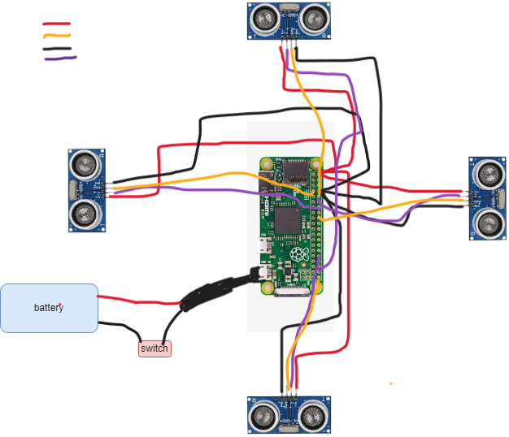

Fig 2.1.1: Circuit diagram

here the red cable is vcc cable or power cabe , the black one is gnd , the yellow one is the echo and the purple one the trigger cable , which are connected to respected gpio pins

we have connected the vcc of all to one common gpio pin 2 , and similarly the ground to gpio pin 6

and the other trigger and echo pins as couples ( for north(20,21 gpio pins), (for south (14,15 gpio pins) , (for east (16,17 gpio pins) , (for west (8,10 gpio pins)

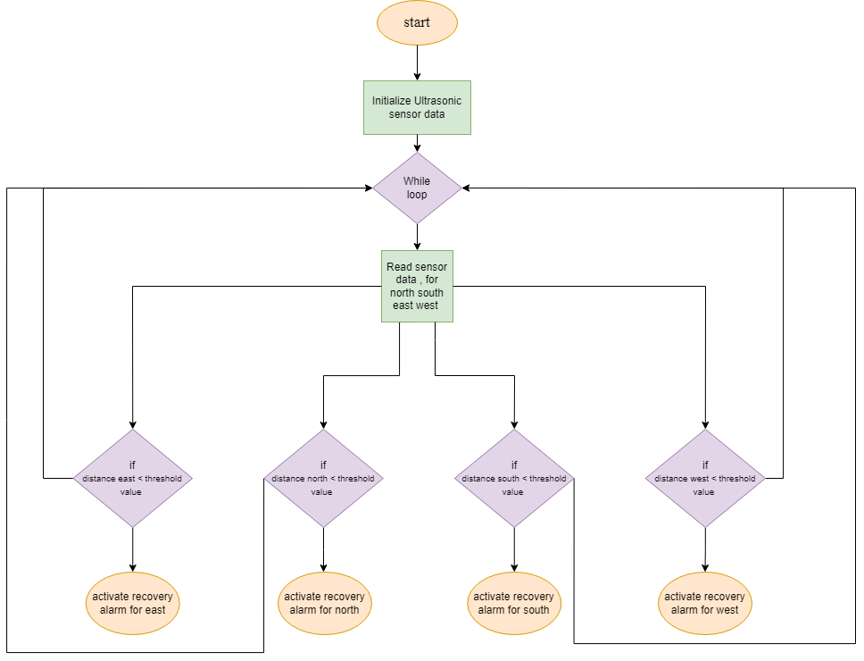**Fig 2.1.2:flow chart**

to give allert message to blind persons we have made a voice assistant which if the object is detected under 60cm it starts allerting

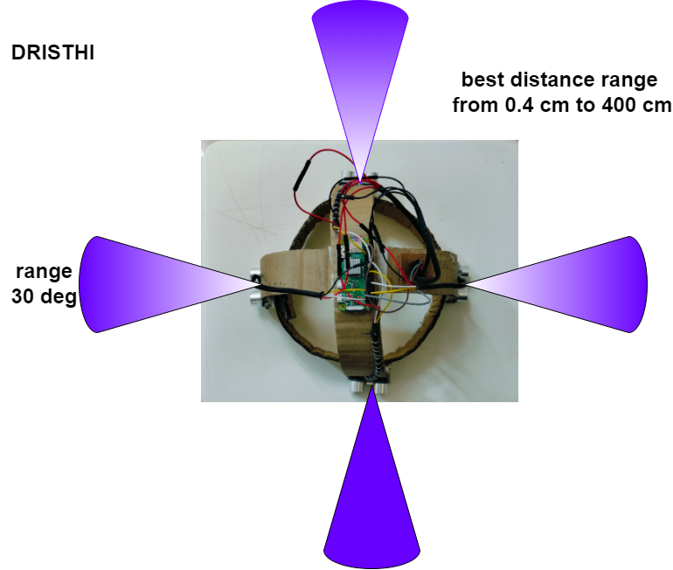

**Fig 2.1.3:range**

our prototype provides about roughly 30degress of range and 0.4 to 400 cm accurate range with respect to distance.

## 2.2 HARDWARE AND SOFTWARE REQUIREMENTS

**2.2.1 HARDWARE REQUIREMENTS**

1. Raberry pi zero w
2. ultra sonic sensors ~ 4
3. 9v battery
4. dc to dc voltage regulator
5. jumper wires
6. display , keyboard and ,mouse

**2.2.2 SOFTWARE REQUIREMENTS**

1. thonny ide

**2.3 DESIGN DETALS :**

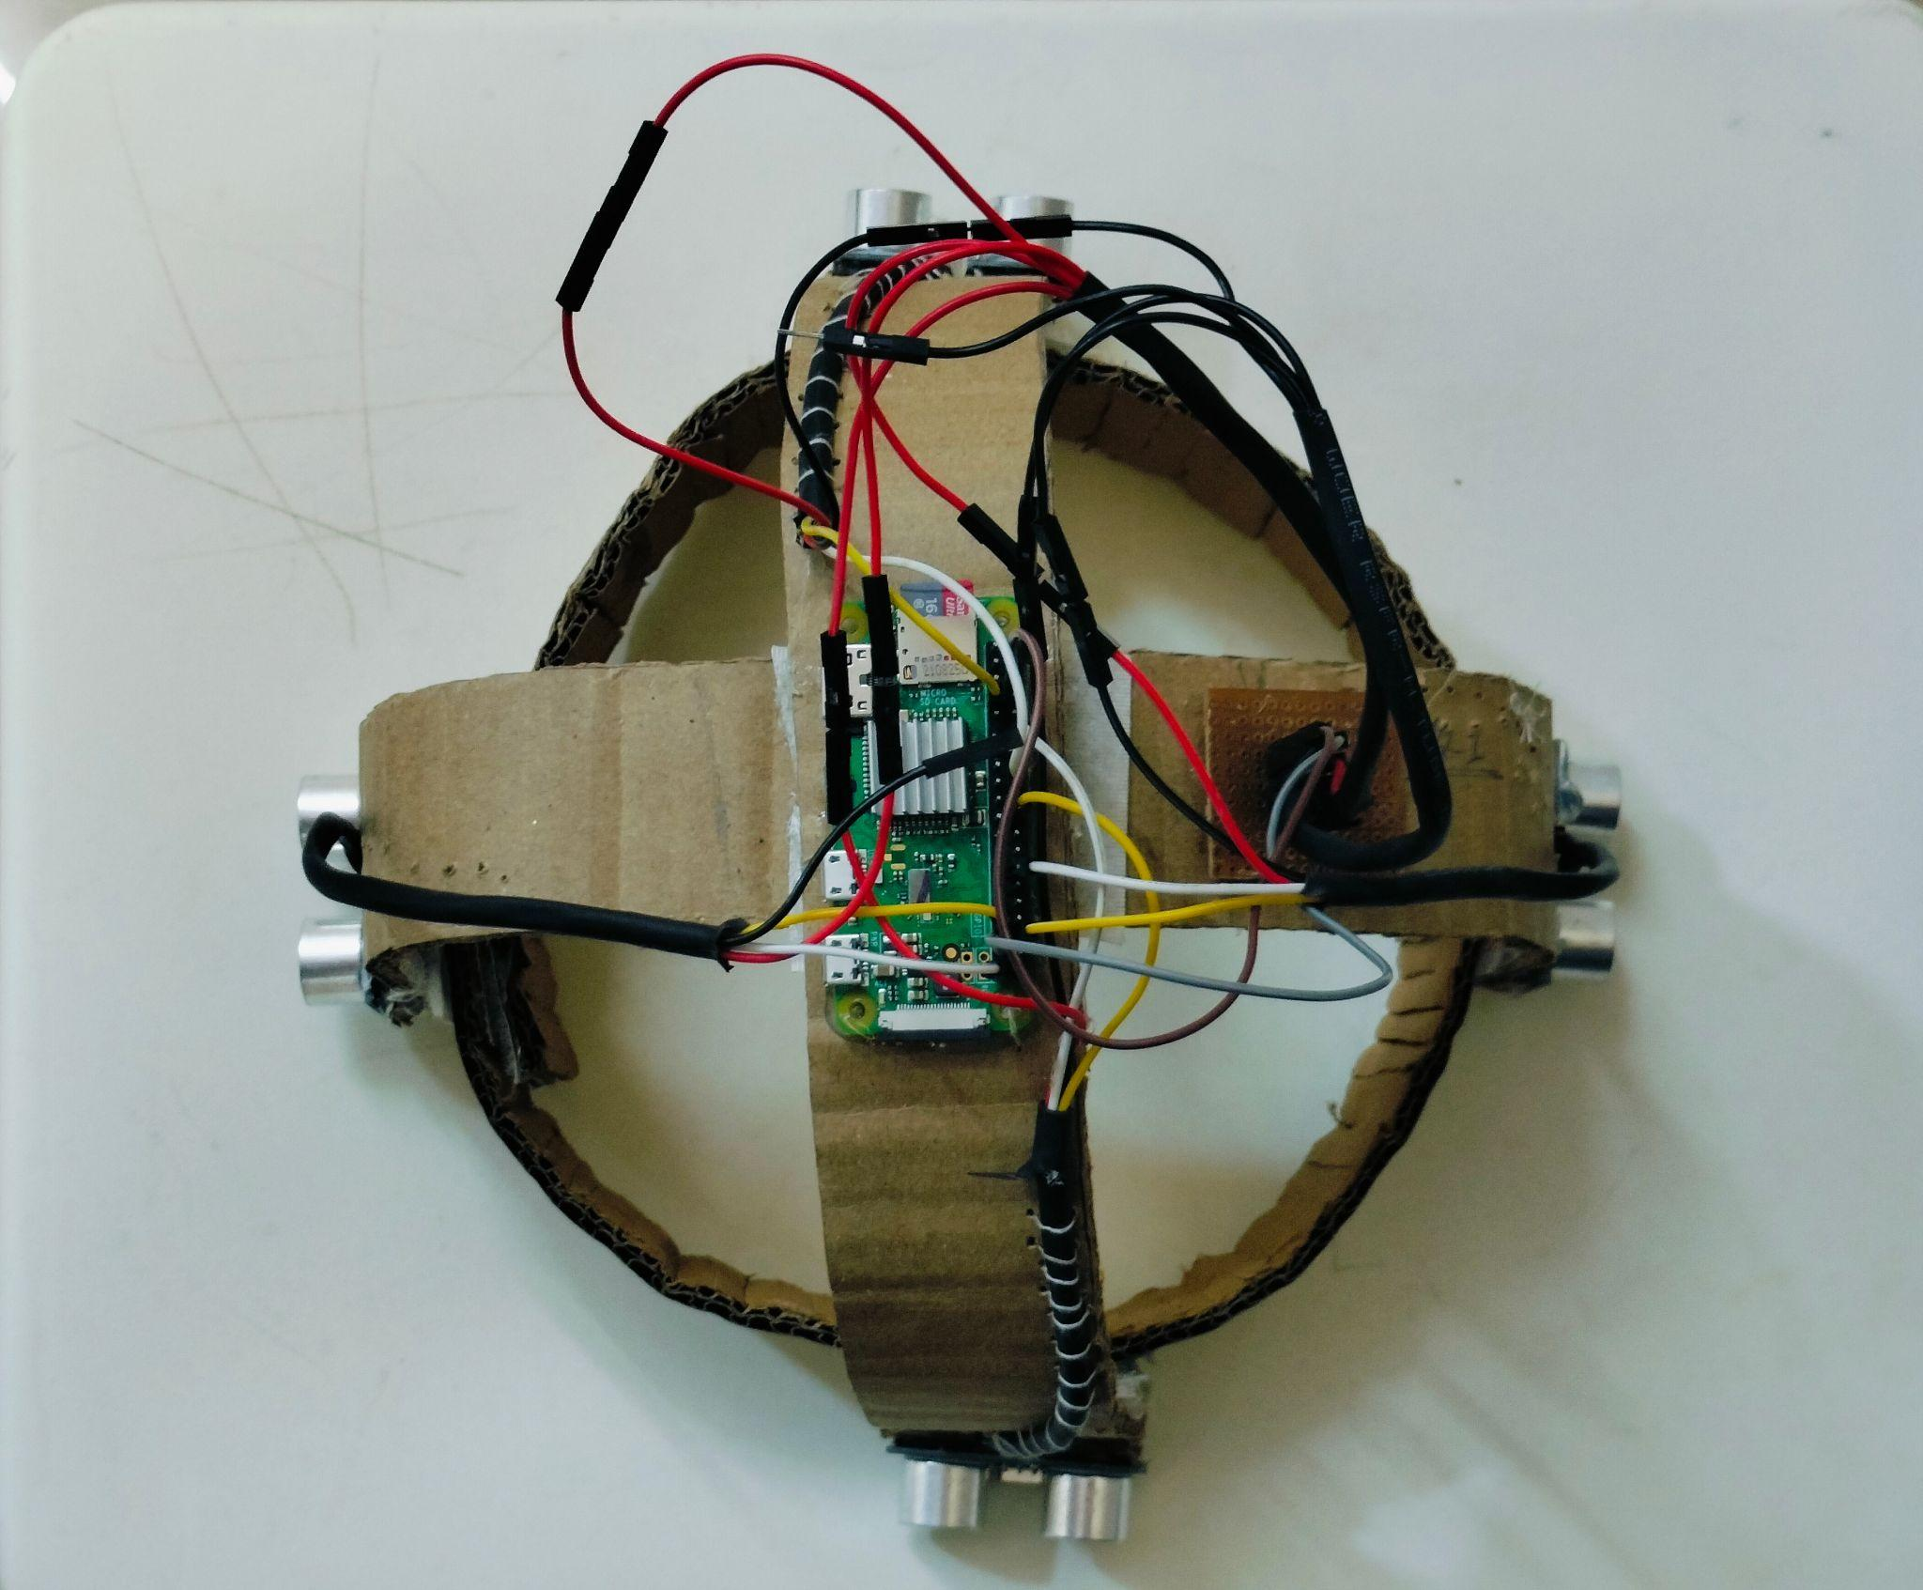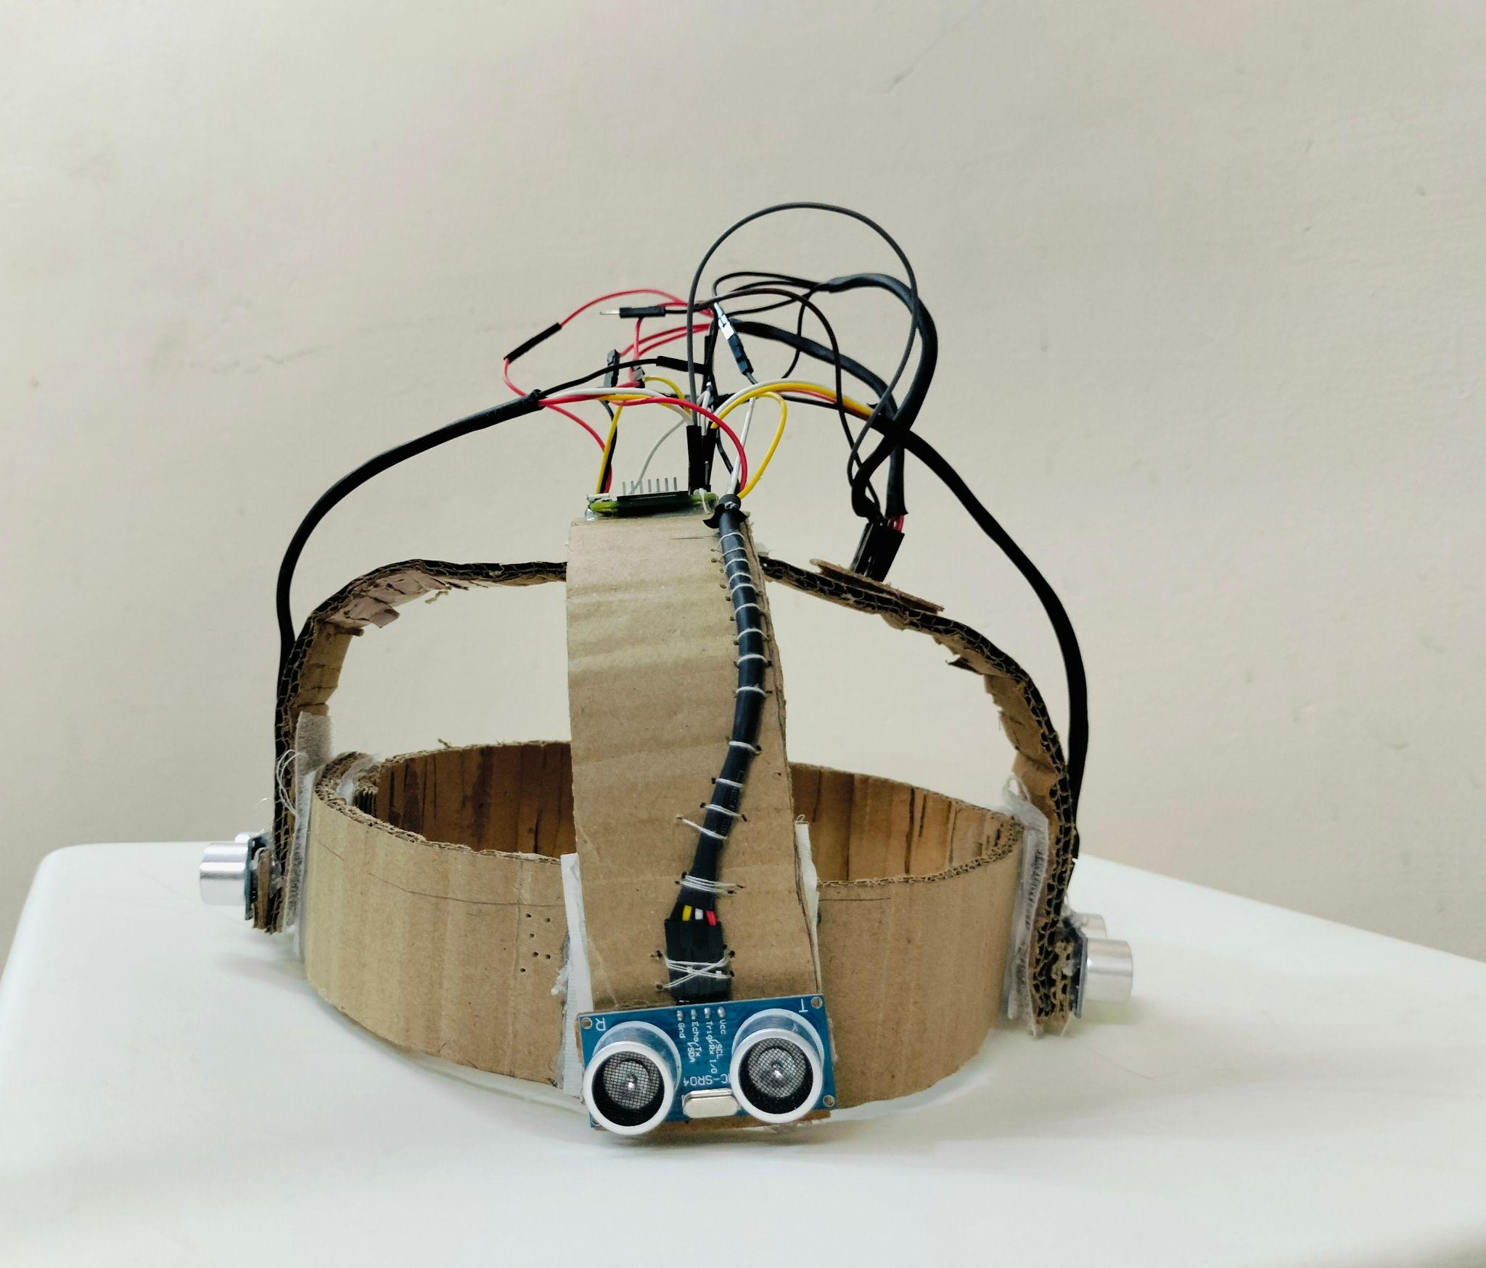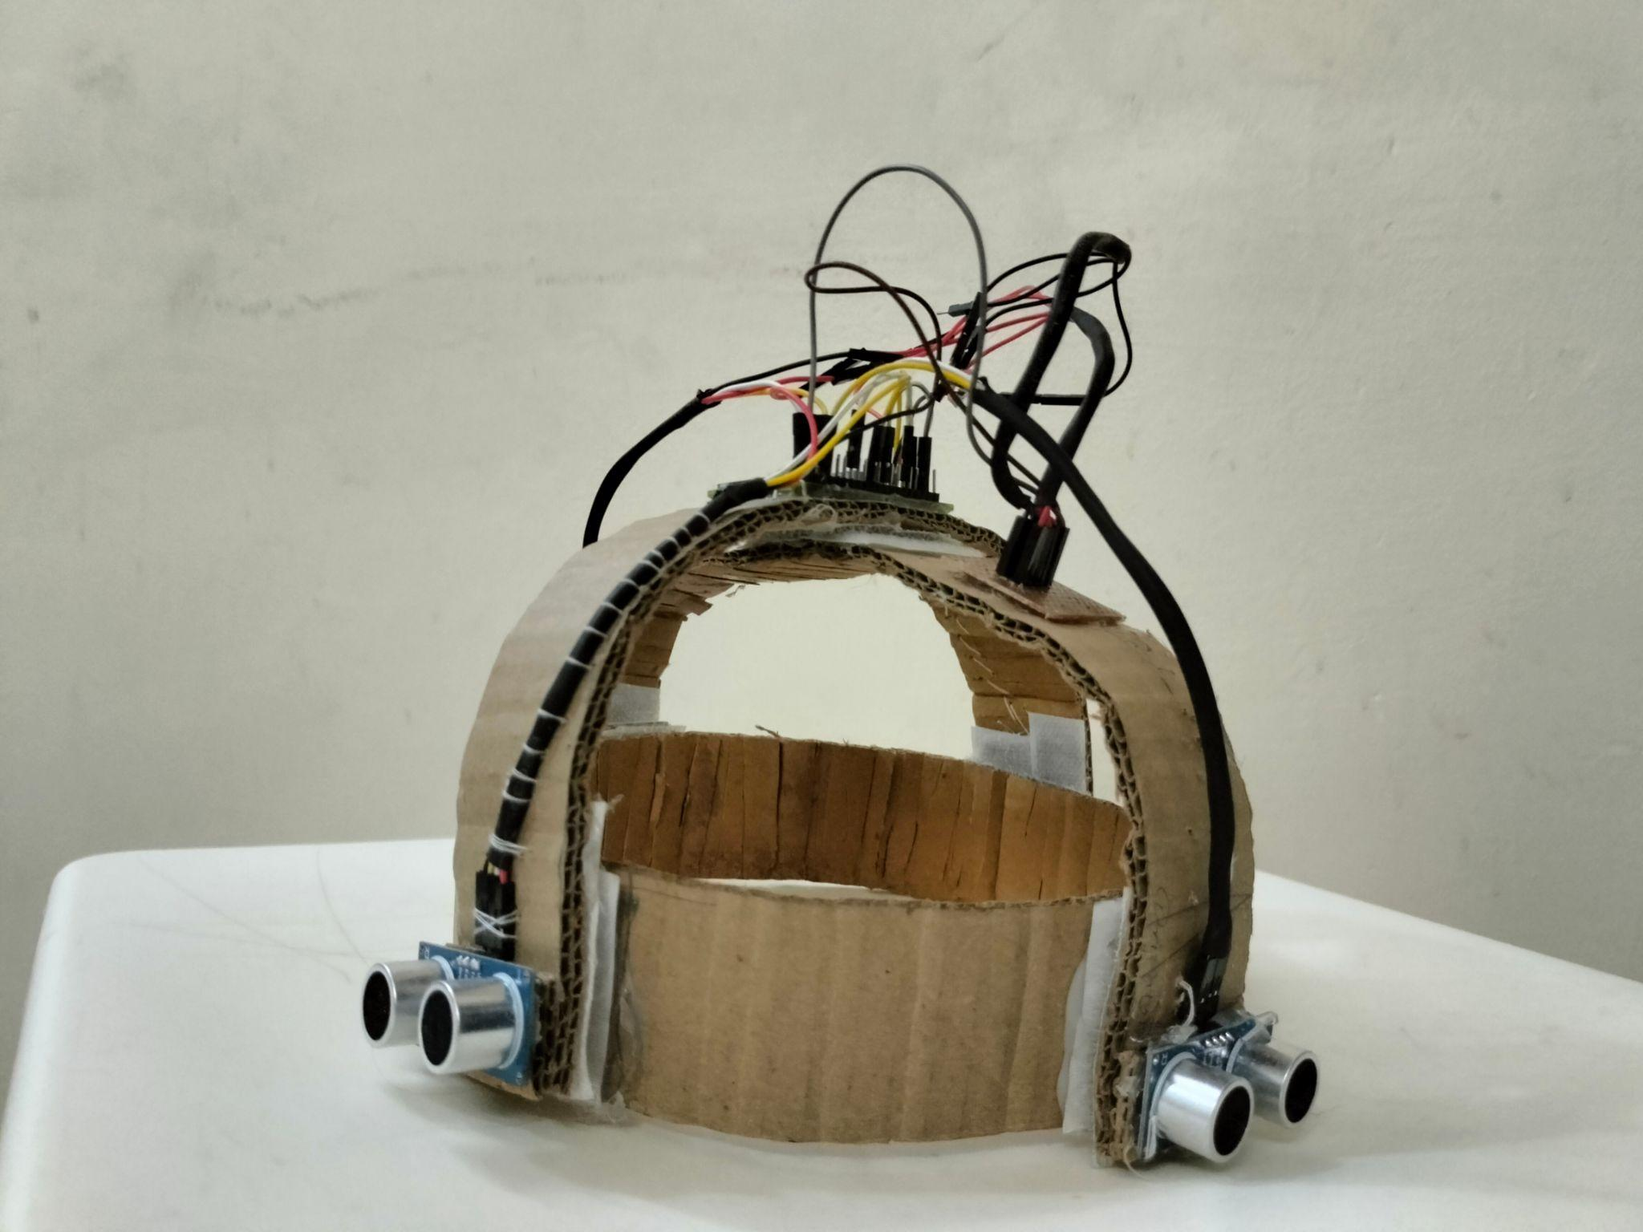

we have make a light weight adjustable cardboard hat , and every component is attached there , it is so reliable , flexible and easy to carry

**CHAPTER 3**

# IMPLEMENTATION AND RESULTS

**3.1 IMPLEMENATAION:**

1. **install rasbian os in raspberry pi zero w**

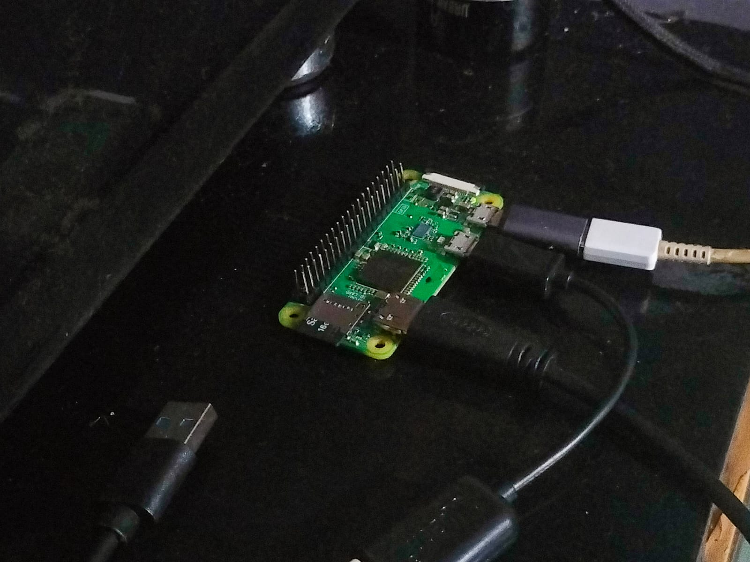

Fig 3.1.1: setup raspberry pi

1. **set up a hedless setup with your raspberry pi and laptop so you can connect it with any location wirelessly**

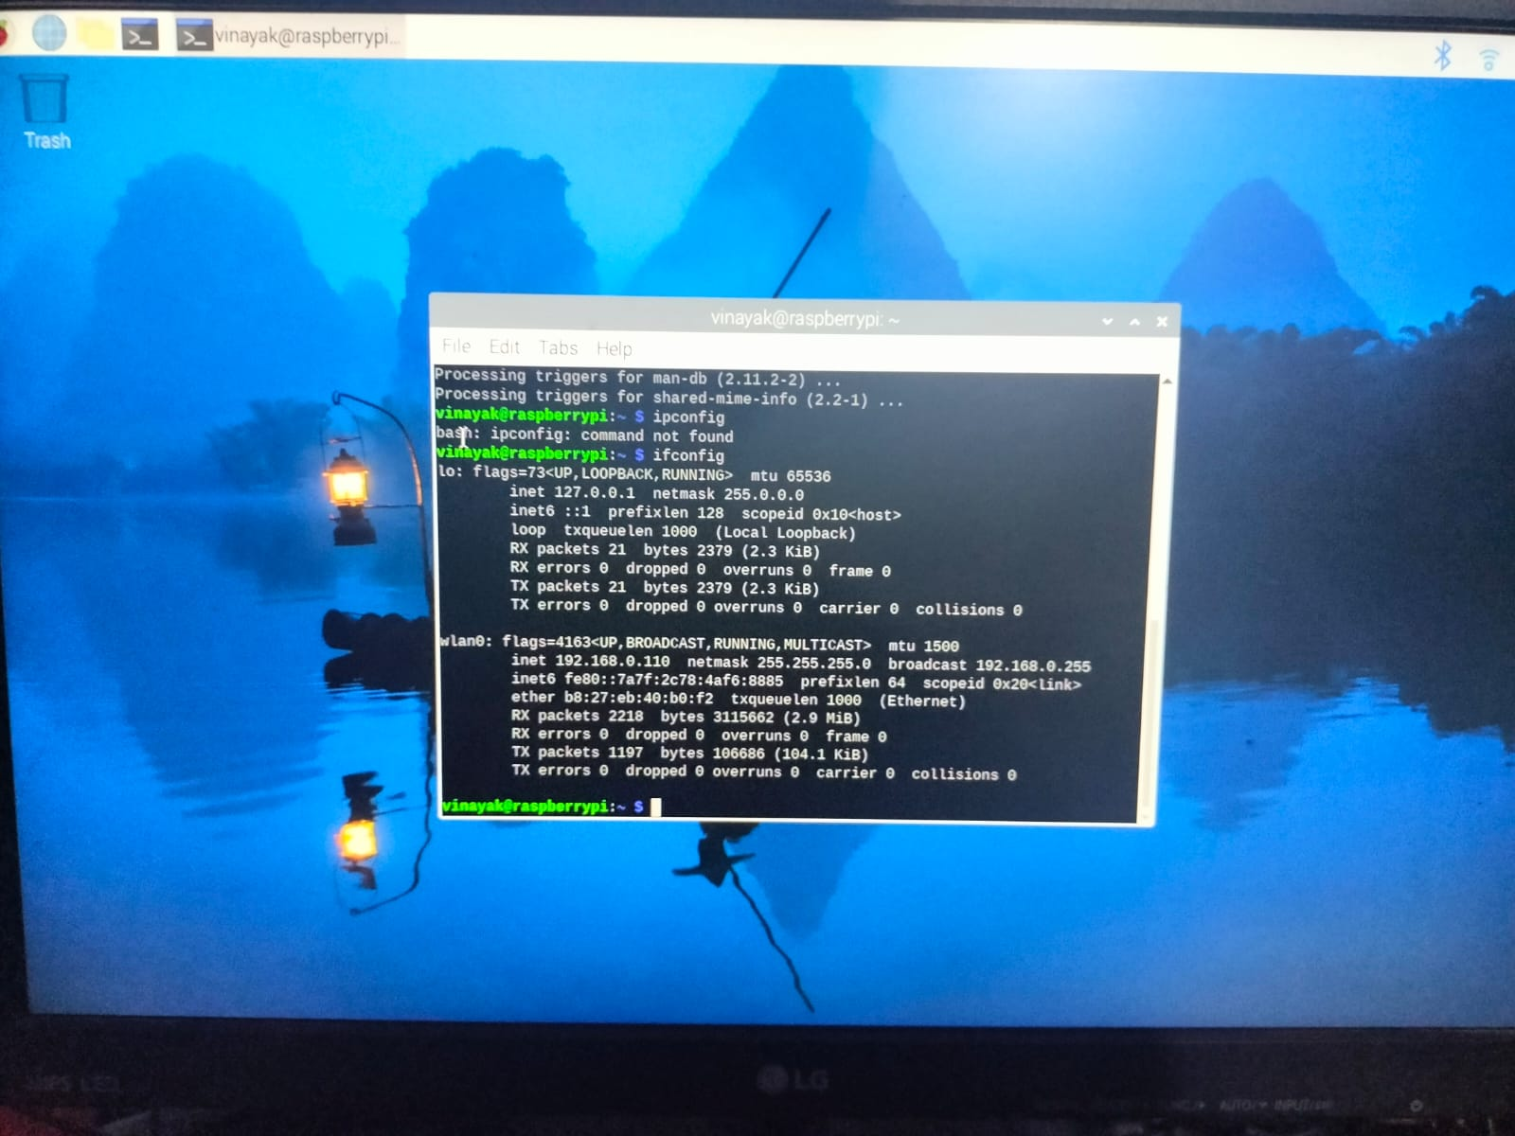

Fig 3.1.1: headless setup raspberry pi

**3. implement for one sensor**

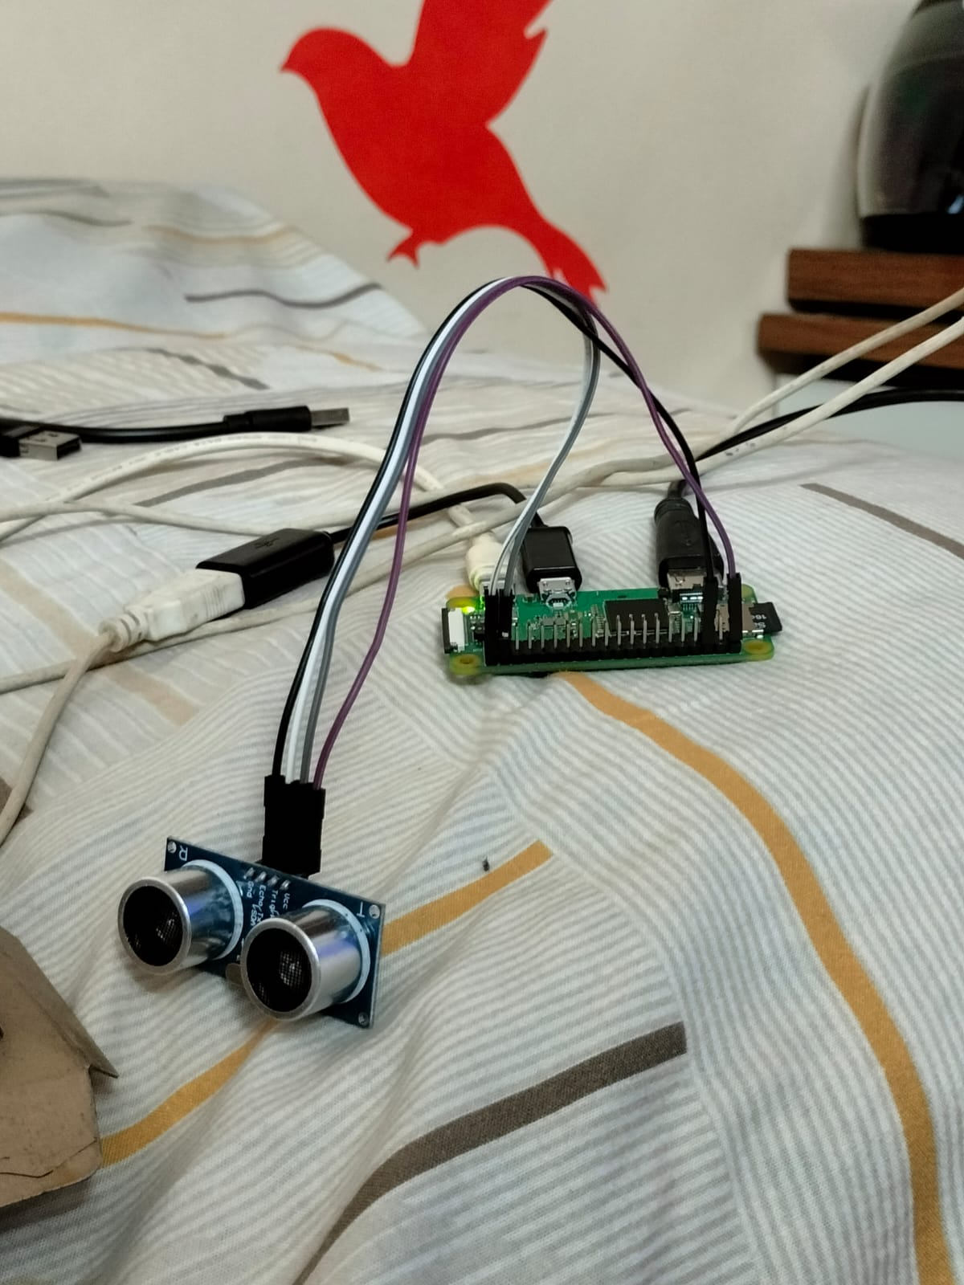

Fig 3.1.1 :implement for one sensor

1. **on successful result connect other 3 sensors to the raspberry pi**

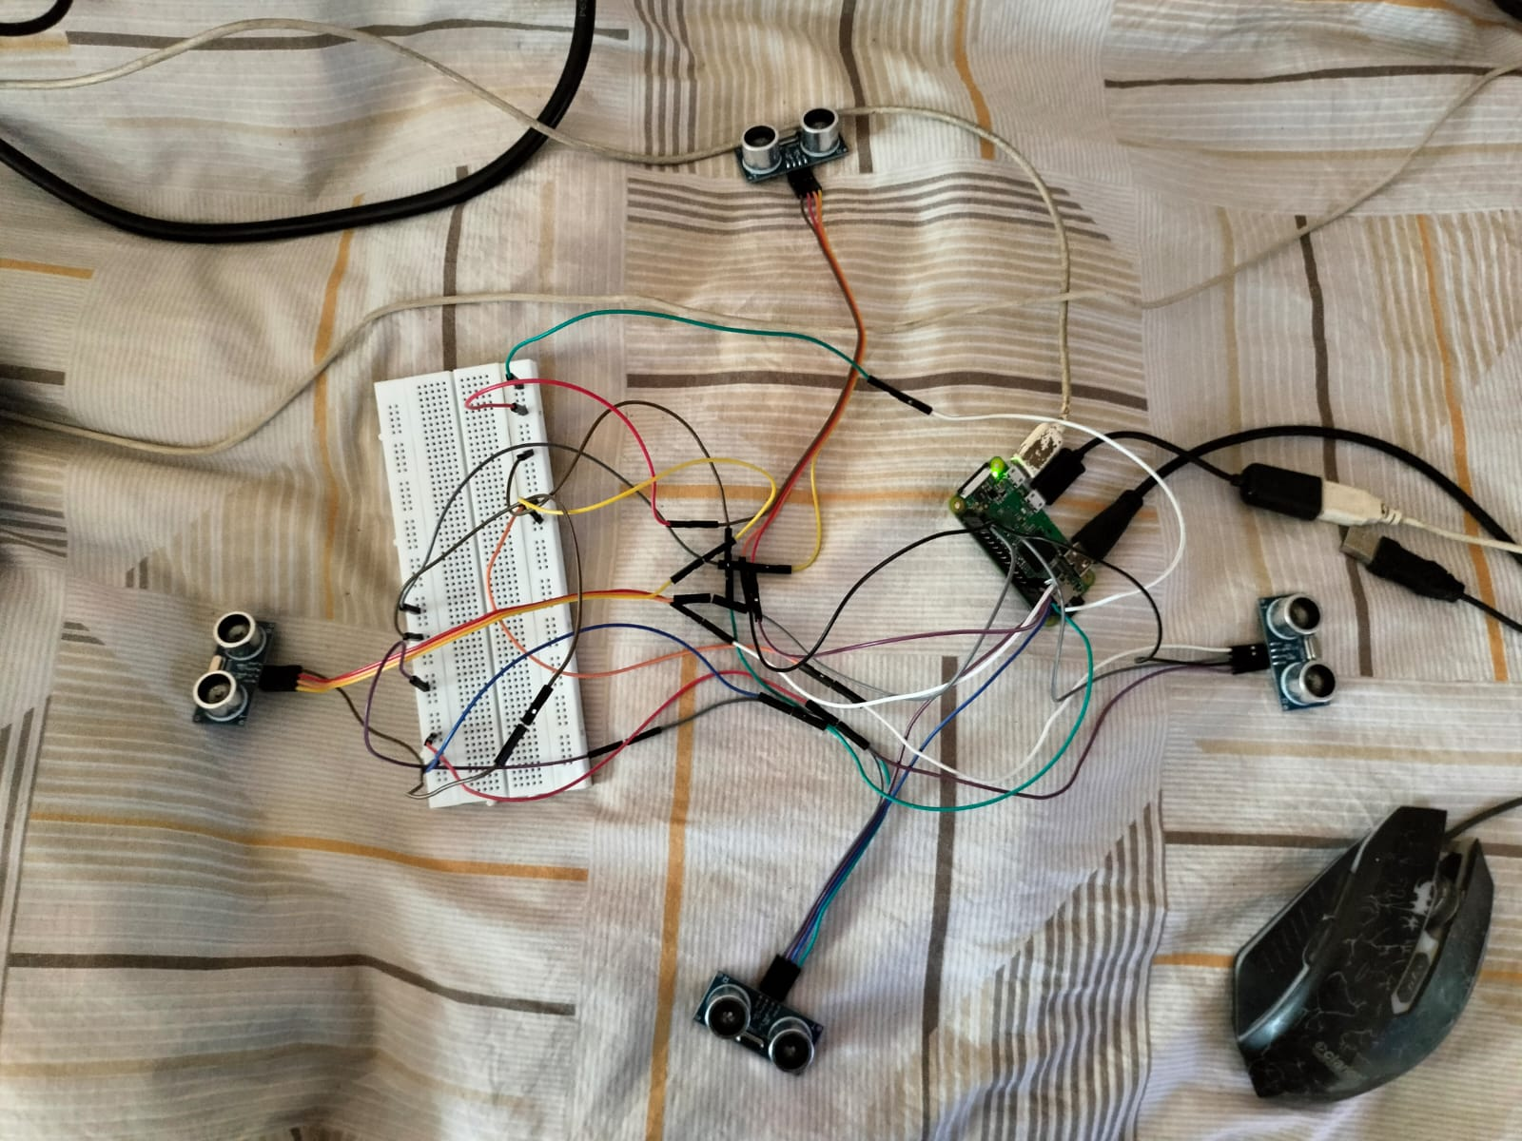

Fig 3.1.1: implementation for 4 sensors

1. **on successful result , start building a simple ai so it can handle the sensors and build the main code according to the flowchart above in algorithm section**

**3.2 RESULTS:**

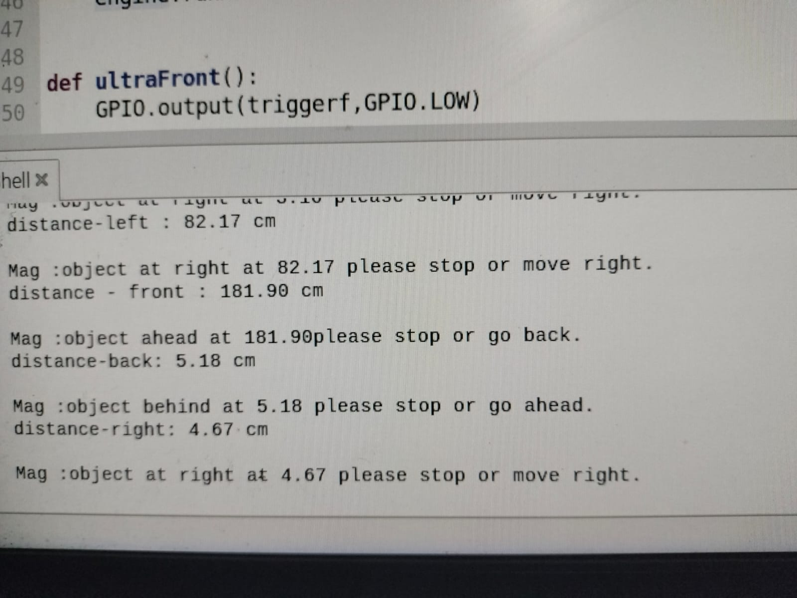

**these are some results of our project**

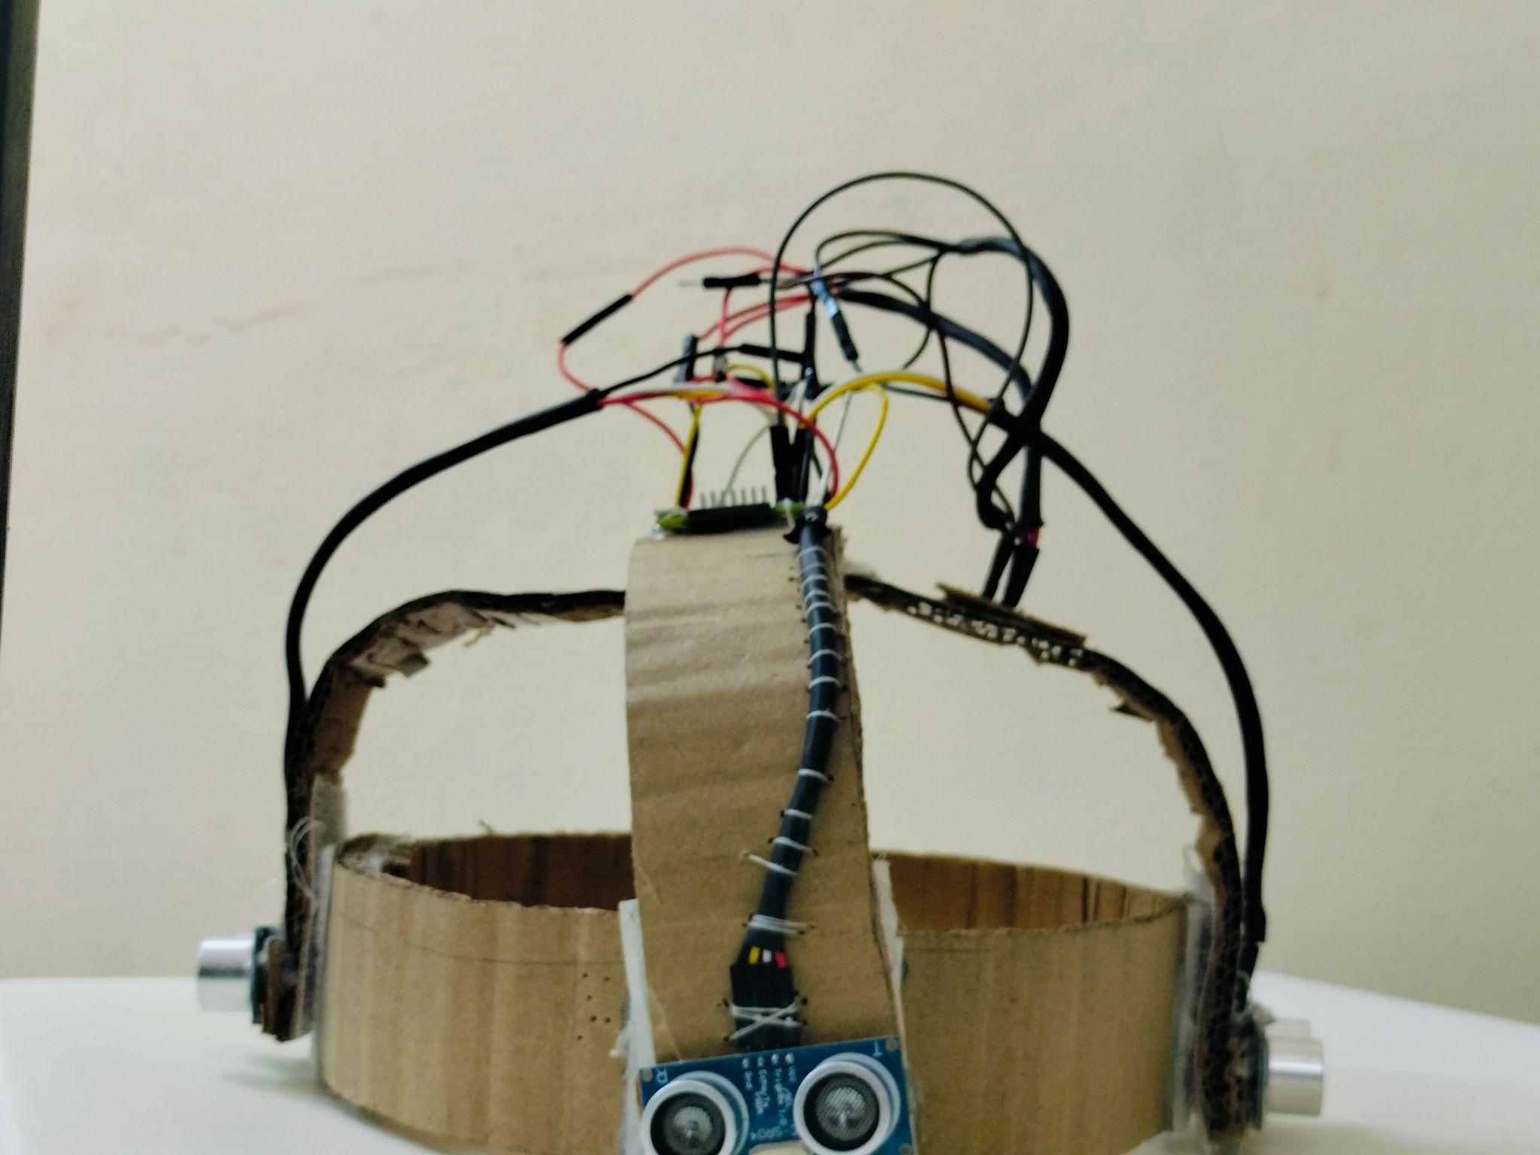

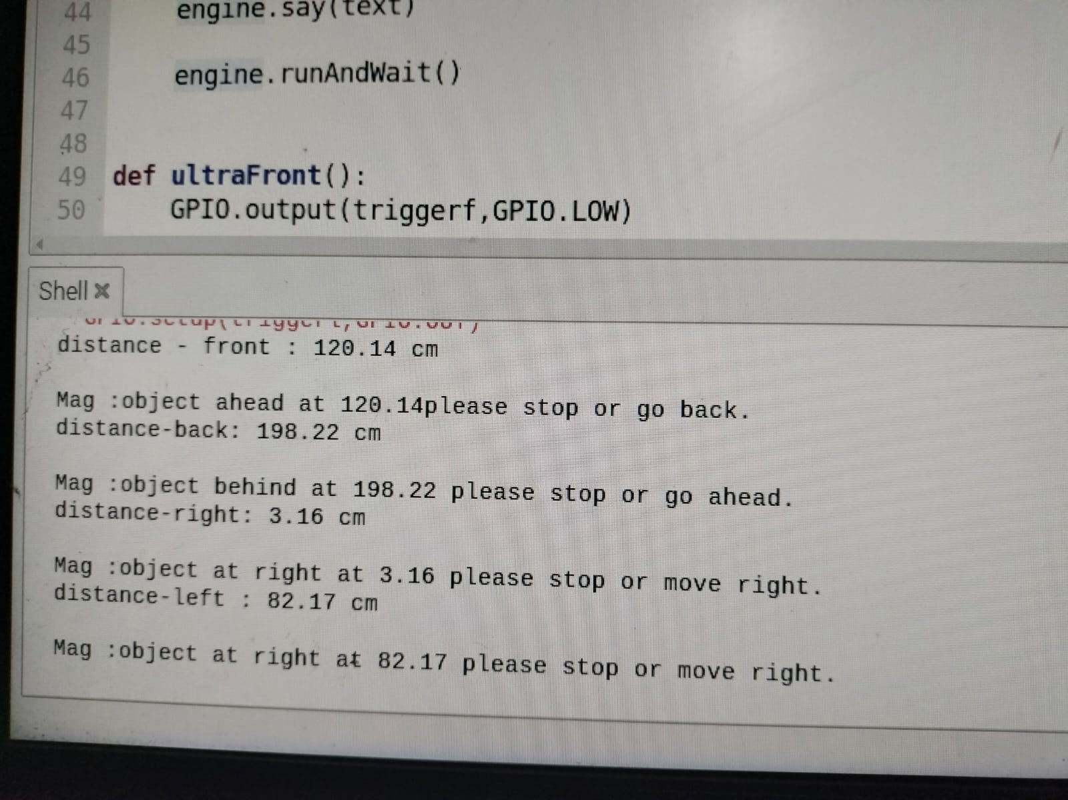

**as we can see it detects the distance from 0.3 cm to utmost 400 cm accurately , and it speak so the user gets allert of the obstacle.**

**CHAPTER 4**

# CONCLUSION AND FUTURE SCOPE

The development of Dristhi, our blind navigation system, marks a significant step forward in enhancing the independence and safety of visually impaired individuals. By integrating ultrasonic sensors, voice assistance, GPS connectivity, and a camera, Dristhi provides real-time obstacle detection, location tracking, and visual feedback to users and their guardians. The system aims to empower users to navigate their surroundings with confidence while also providing peace of mind to their loved ones.

As we move forward, there are several avenues for further improvement and expansion of Dristhi:

1. **Enhanced Sensor Technology**: Continuously improve the accuracy and range of sensors to detect obstacles more effectively, even in challenging environments.

2.**Advanced Navigation Algorithms**: Develop more sophisticated algorithms for path planning and navigation, taking into account real-time traffic conditions, terrain information, and user preferences.

3.**Integration of Machine Learning**: Utilize machine learning techniques to improve obstacle recognition, optimize voice assistance, and personalize the user experience based on individual behavior patterns.

4.**Mobile App Developmen**t: Expand the capabilities of the mobile app to provide additional features such as route planning, emergency assistance, and community-based navigation support.

5. **Accessibility and Usabilit**y: Conduct user studies and feedback sessions to ensure that Dristhi remains intuitive, user-friendly, and accessible to individuals with varying levels of visual impairment.

**CHAPTER 5**

# REFERENCES

* 1. "Ultrasonic Sensor-Based Obstacle Detection for Visually Impaired People" by Siddharth S. Arya et al. (https://ieeexplore.ieee.org/document/8473440)
* 2. "Smart Navigation System for Visually Impaired People Using IoT and Deep Learning" by Samir S. Patel et al. (https://ieeexplore.ieee.org/document/9026612)
* 3. "Real-Time Obstacle Detection and Navigation for Visually Impaired Using Ultrasonic Sensor" by Ankit Shrivastava et al. (https://ieeexplore.ieee.org/document/8941085)
* 4. "A Review on Smart Navigation System for Visually Impaired People" by Deepak B. Mahajan et al. (https://link.springer.com/article/10.1007/s42452-019-0745-4)
* 5. "Design and Implementation of an Intelligent Assistive Navigation System for Visually Impaired People" by Mohammed N. Mohammed et al. (https://www.sciencedirect.com/science/article/pii/S1877050919315441)
* These references provide valuable insights, research findings, and technological approaches relevant to the development of Dristhi, serving as a foundation for further innovation and refinement of the project.